*You can check out class novels from either campus book room*

- Find the links to the websites on JTWEB>Campus Resources>Central or West:

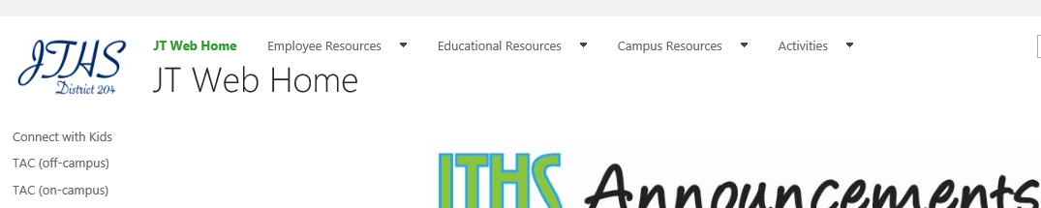

- Browse through titles and decide which one you will request. Titles are linked to the GoodReads summary and reviews. Also, each title has the Lexile level and inventory amount listed below its cover picture. Now, click on the “Click here to Request Books” link.

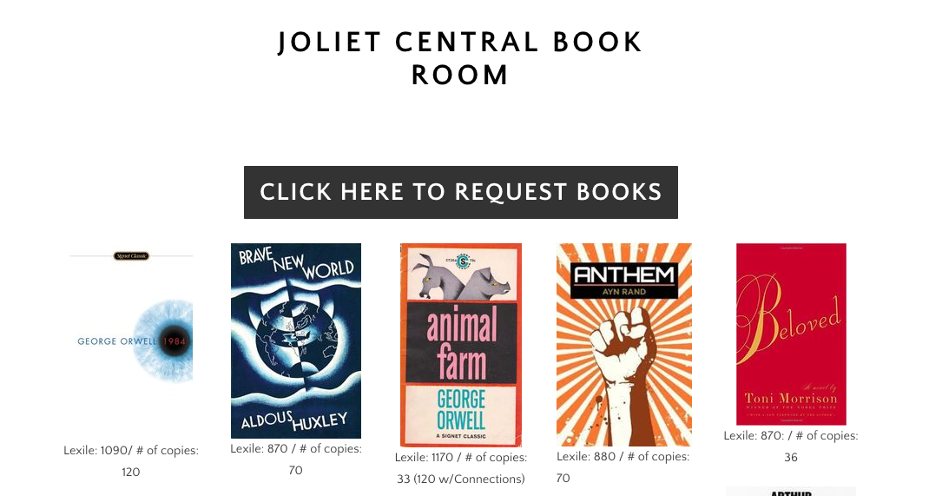

- Choose “+ New Item” on the SharePoint list. Fill in the request. Mary Kay Wheeler at West (mwheeler@jths.org) or Grace Gonzalez at Central (ggonzalez@jths.org) will facilitate the requests and delivery on campus or between campuses. Through this SharePoint, you will also be able to see if your novel choice has already been checked out.

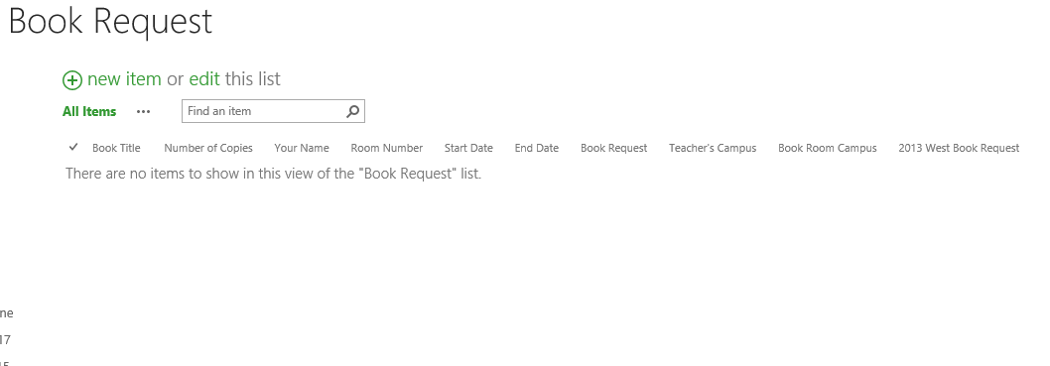

- *Please remember to keep a record of student names, ID numbers, and assigned novel numbers. This way, you can collect and return the exact amount and/or report missing or damaged texts.

*Missing or damaged texts: If a novel is not returned or is returned damaged, you should report the student name, ID number, and book title to the campus book room facilitator, Mary Kay Wheeler at West (mwheeler@jths.org) or Grace Gonzalez at Central (ggonzalez@jths.org). Students will then incur a fine on their student account. Likewise, the campus book room facilitator will then be able to adjust the inventory and report this loss to the Content Coordinator.

